**Graded Assignment On Serverless Architecture**

**Question1: Automated Instance Management Using AWS Lambda and Boto3**

1. Created 2 Ec2 instance ag one of them as `Auto-Stop` and the other as `Auto-Start`.

import boto3

# Initialize the EC2 client

ec2 = boto3.client('ec2')

# Create instances

instances = ec2.run_instances(

ImageId='ami-0cf2b4e024cdb6960', # Replace with your AMI ID

MinCount=1,

MaxCount=2,

InstanceType='t2.micro', # Replace with your desired instance type

KeyName='tm', # Replace with your key pair name

SecurityGroupIds=['sg-0ed28da5ff37a789d'], # Replace with your security group ID(s)

)

# Get instance IDs

instance_ids = [instance['InstanceId'] for instance in instances['Instances']]

# Tag instances

for instance_id in instance_ids:

if instance_id == instance_ids[0]: # First instance is tagged as 'Auto-Stop'

ec2.create_tags(

Resources=[instance_id],

Tags=[

{'Key': 'Name', 'Value': 'Auto-Stop'}

]

)

else: # Second instance is tagged as 'Auto-Start'

ec2.create_tags(

Resources=[instance_id],

Tags=[

{'Key': 'Name', 'Value': 'Auto-Start'}

]

)

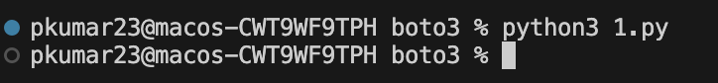



1. Lambda function has the necessary IAM permissions to describe, stop, and start EC2 instances.

3.Using Boto3 in the Lambda function: Detect all EC2 instances with the `Auto-Stop` tag and stop them and Detect all EC2 instances with the `Auto-Start` tag and start them.

4. Manually invoked the Lambda function.

Confirmed that the instance tagged `Auto-Stop` stops and the one tagged `Auto-Start` starts.

**Question 2:** **Automated S3 Bucket Clean-up Using AWS Lambda and Boto3**

1. Created s3 bucket

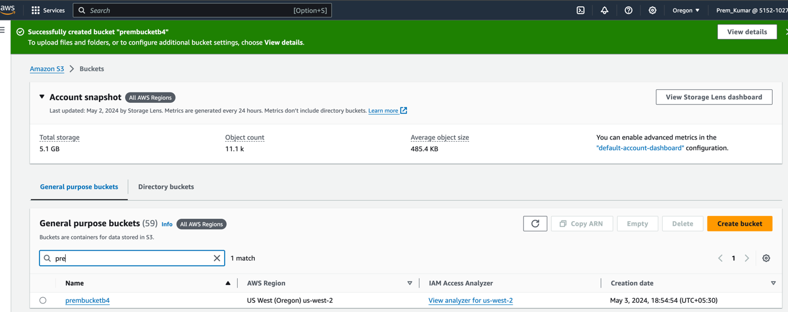

1. Created the IAM role and attached the policy Amazon

1. Navigated to the Lambda dashboard and create a new function.

Boto3 Python script to

* Initialize a boto3 S3 client.
* List objects in the specified bucket.
* Delete objects older than 30 days.
* Print the names of deleted objects for logging purposes.

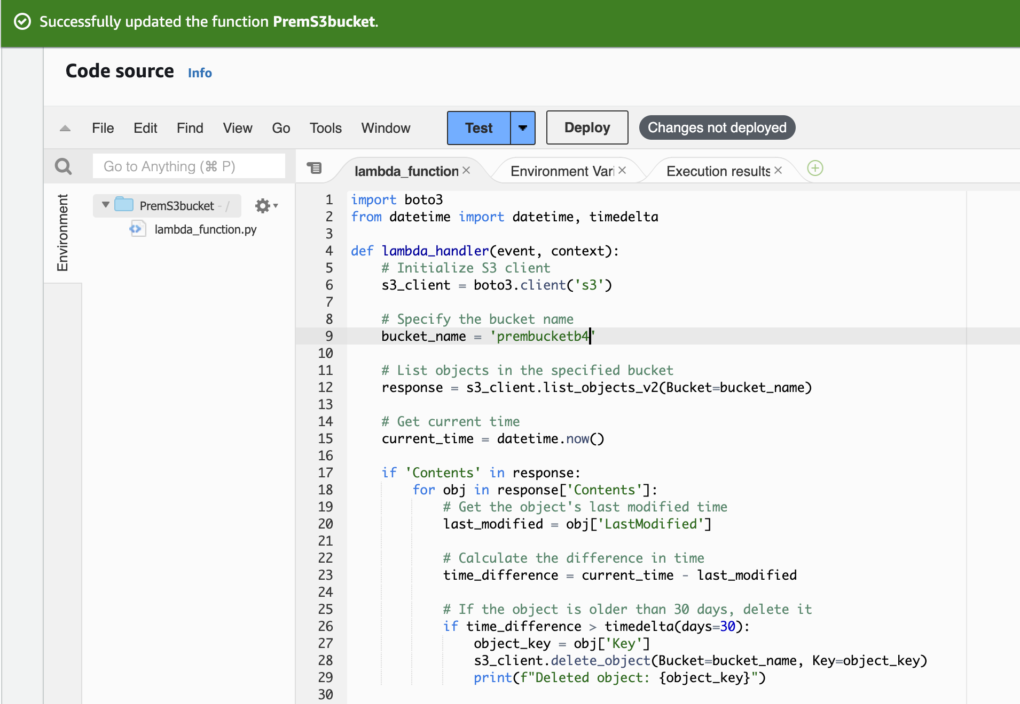

Manual Invocation:

* After saving your function, manually trigger it.

Confirmed : It has deleted the a objects which are created more than 30 days.

**Question 18 : Restore EC2 Instance from Snapshot**

Automated the process of creating a new EC2 instance from the latest snapshot using a Lambda function.

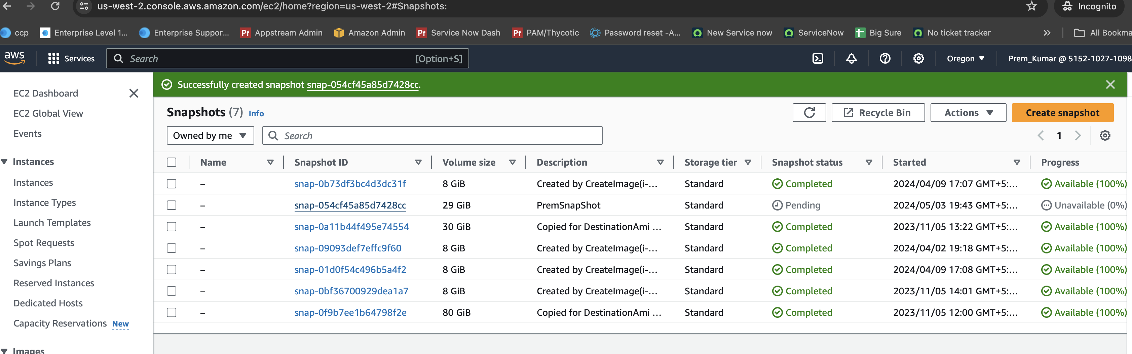

Created Lambda function Using Boto3, the function should fetch the most recent snapshot of a given EC2 instance. Create a new EC2 instance using the fetched snapshot.

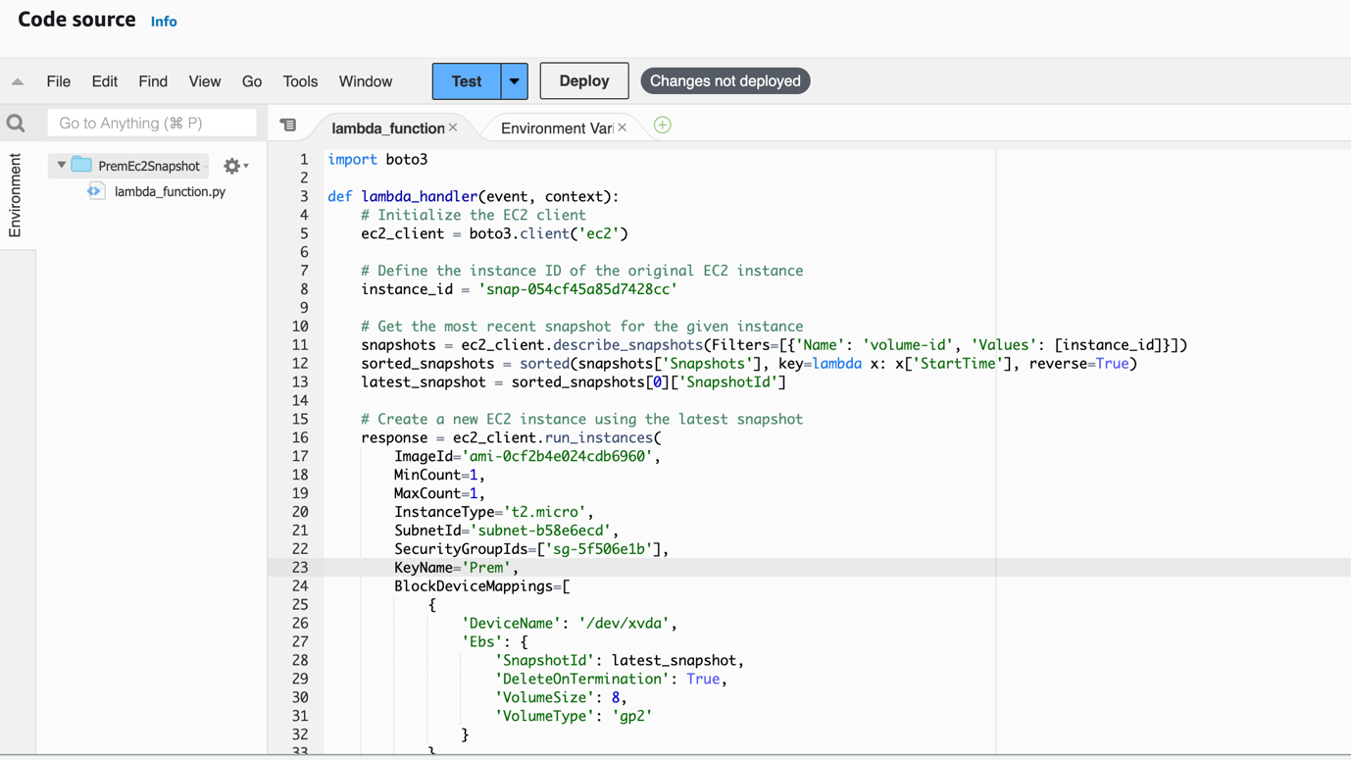

Trigger this Lambda function manually or on a schedule, depending on your recovery requirements.

Finally : It has create a Ec2 instance with key name Prem and latest snapshot added to it.

**Question 16 :Implement a Log Cleaner for S3**

Create a Lambda function that automatically deletes logs in a specified S3 bucket that are older than 90 days.

* Using Boto3, configure the function to:
* Access the specified S3 bucket.
* List all the log files.
* Check the age of each log.
* Delete logs older than 90 days.

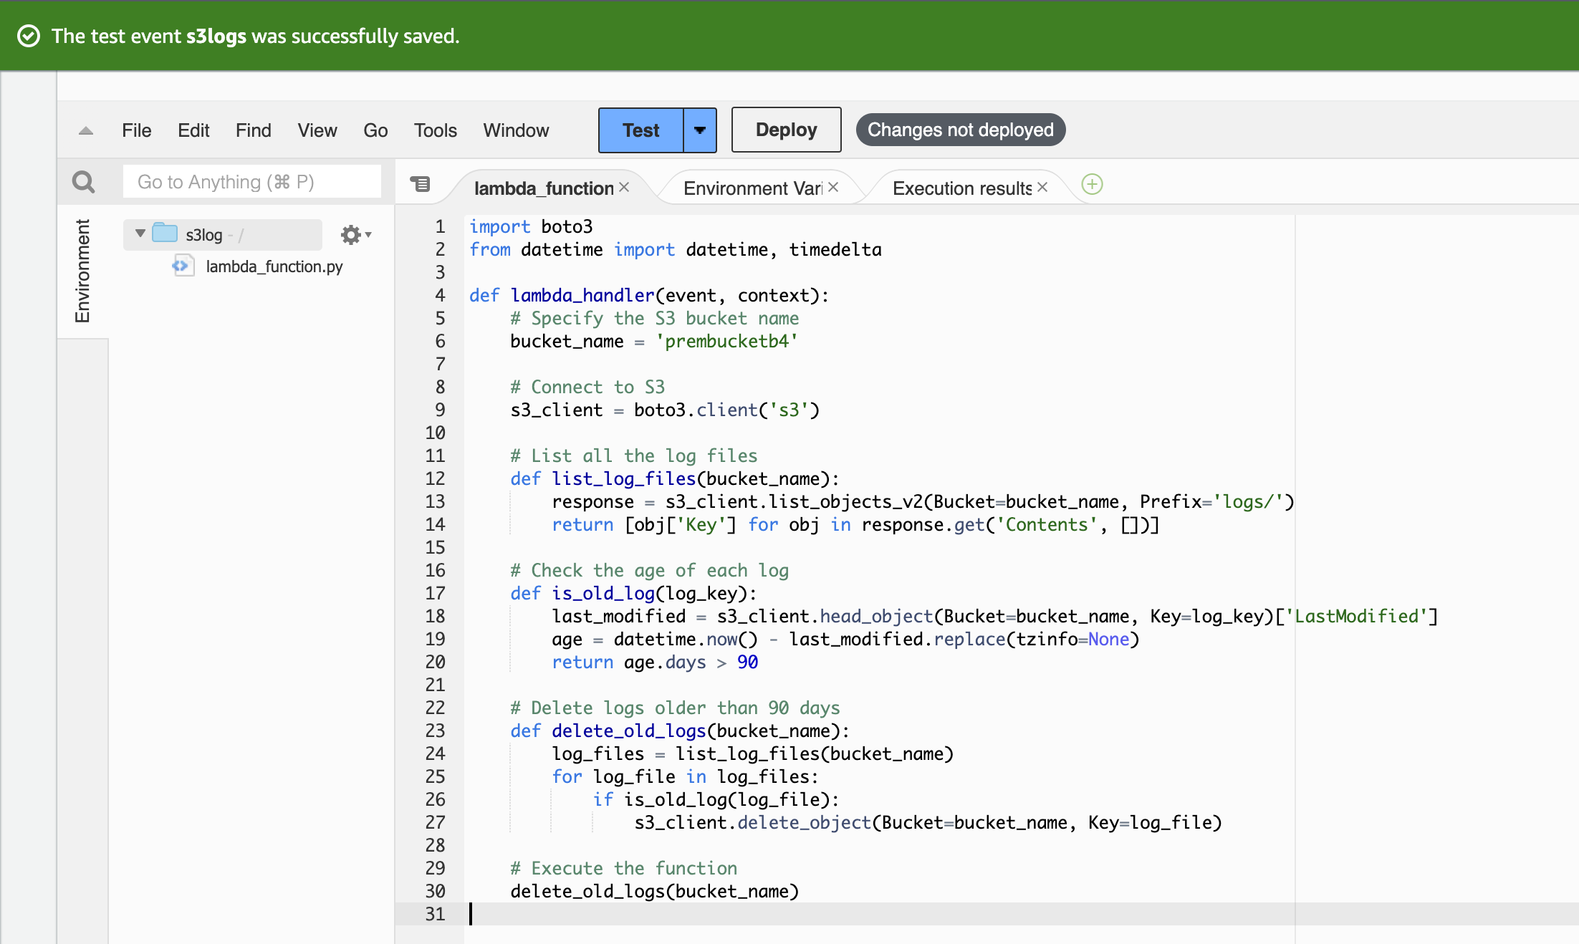

Scheduled this function to run weekly using AWS Event Bridge.

